APP FOR FARMERS TO SELL THEIR PRODUCTS TO CUSTOMER, RETAILERS AND GOVT TENDERS

AGRI PRODUCTS

PROBLEM

Third parties {brokers} fixing their own rate for the Agri products and selling the products to the customers and the industrial units with huge amount of profit for producing outputs.

SOLUTION

farmer => customer

farmer => retailer

farmer => industries

farmer => govt tenders

Farmers can sell their own products through online without third party’s {brokers} to the people and industries.

ABSTRACT

Making Agri products directly available to sell from farmers to the consumers

by quoting their own fixed rate for their own cultivating product with huge amount of profit.

Types of users

* Farmer
* Customer
* Retailer
* Manufacturing Industries
* Delivery Persons or Delivery Partners
* Admin

USER CAMPAIGN

It is necessary to demonstrate the application details before the usage of application. People should know the details, facilities and benefits of the app. So, app campaign is necessary to conduct before launching the application.

MODULE 1 [ FARMERS]

* Farmer has to register themselves into the application by educating them to know about the application and how can they sell their products and the application should be available in all the native languages AND also providing them the video tutorials for using the application.
* A profile to be created to the each and every farmer who registered themselves into the application.
* After completing the registration process and profile setup execution there will be an id proof submission is necessary to avoid unwanted confusions regarding the legal problems.
* There are lot of offers and discounts to be provided based upon their product moved through our application.
* Farmers can add their product name and about the product description.
* They should add product quantity, product picture and also have to quote the product price and location.
* Such that, when the customer and retailer and product-based companies search for a particular product they can able to get immediate results.
* Based on the geographical location and the availability of products with the farmers, customers, retailers and product-based industries may easily get identify the product within the available location.
* Farmers have to link their bank accounts with our application to get the immediate mode of payment transaction.
* Farmers will get payment through our admin via available payment options currently available in the market.
* There will be a multiple delivery partners and delivery services which are available in the particular area will be associated with our app so when they can easily pickup the product when the customer or retailer chooses the product to buy.

MODULE 2 [ COSTUMER, RETAILERS, INDUSTRIES]

* costumer has to register themselves into the application by educating them to know about the application
* And how can they buy their products and the application credentials should be available in all the native languages and also providing them the video tutorials for using the application.
* A profile to be created to the each and every farmer who registered themselves into the application.
* After completing the registration process and profile setup execution there will be an id proof submission is necessary to avoid unwanted confusions regarding the legal problems.
* Similarly, like farmer module, there are lot of offers and discounts to be provided based upon their product moved through our application for the customer and retailers like wise monthly basis.
* Based on their requirements and based on their price value they can able to filter the products.
* And also depending upon the geographical location of the product they can able to filter the items what they actually need.
* Once the order is filtered the results will be displayed and also there will be an option called Wishlist or add to cart to save the particular product for some available time period.
* If they ordered the product the page will automatically redirected to delivery partners page to select the kind of delivery partner.
* The delivery partners will get a notification regarding to the kind of product ordered by the customer through our admin notification.
* Based on the geographical location the nearby delivery partners can able to reach the nearby delivery partners can get into action.
* After that the customer choosing the delivery partner, customer will enter into the payment option method whether it is by cod or by instant payment.
* If they order the products and they have to select the mode of payment options available in our application.
* payment section happen through our admin and the admin will split up the payments to the farmers and the payments are done with currently available payment option methods in the market

MODULE 3 [ ADMIN & DELIVERY PARTNERS]

* Admin has the control to manage the each and every process of payment happened through the application.
* The management has the separate databases regarding the products listed, ordered, delivered and other data’s regarding to the farmer, customer and the retailers.
* Main work for admin is to check the proper order details about the farmer, customer queries to help them for selling and buying the products.
* Admin will tie up with the delivery partners available to the nearby surrounding areas of farmer to pickup the product and will sure make themselves to deliver it to the customer.
* Once the customer chooses the product to buy and they have to select the delivery partner, if they selected the delivery partner notification to be sent to the delivery partner through our application.
* The delivery charge to be charged from the farmer and also from the customer at reasonable price.

WORK FLOW

[FUNCTIONALITIES]

HOME PROFILE

SELECT LANGUAGE

SEARCH

SUBMIT

video tutorial

play

**farmer login customer login**

New user?

**sign up** => registration process => id proof submission & id verification.

LOGIN CREDNTIALS

***farmer login***

select

@ user id => enter id => submit

@ password => enter password=> (forget password) => send otp => login

Farmer profile rewards & earnings

Profile setup check

submit

product profile

update product profile

list products => select

@ product name [turmeric] => add item @ product name =[coconut]

@ product quantity @ product quantity

@ product image @ product image

@ product description @ product description

@ product price @ product price

@ product location @ product location

submit

* sold products => check => list of items sold
* ongoing products => check=> updated in profile

submit

* upcoming products =>list products => add upcoming products =>

submit

**ADDRESS CREDENTIALS** => enter address=>

**TRACK ORDER** => location access => allow

**PAYMENT DETAILS** => Enter details => click ok

**CONTACT ADMIN** => help => queries => contact => call=> WhatsApp=> mail

**# publish # unpublish**

**WORK FLOW**

[FUNCTIONALITIES]

HOME PROFILE

SELECT LANGUAGE

SEARCH

SUBMIT

video tutorial

play

**farmer login customer login**

New user?

**sign up** => registration process => id proof submission & id verification.

LOGIN CREDNTIALS

***Customer login***

Select

@ user id => enter id => submit

@ password =>enter password=> (forget password) => send otp => login

Customer profile rewards & earnings

Profile setup check

submit

Product profile

open

search filter by categories

price

location

submit

By quantity =>

**RESULTS**

SELECT PRODUCT

@ product name =[nuts] + add product => Click to add => @ product name =[coconut]

@ product quantity @ product quantity

@ product image @ product image

@ product description @ product description

@ product price @ product price

@ product location @ product location

**ADD TO CART** => BUY => click ok

submit

**ADDRESS CREDENTIALS** => enter address=>

**TRACK ORDER** => location access => allow

**SELECT DELIVERY PARTNERS**

search

choose

BLUE DART

PROFESSIONALS

DELHIVERY select ok submit

**PAYMENT METHODS** => select=> CREDIT

DEBIT

UPI select click ok to pay

**pay**

**CONTACT ADMIN** => help => queries => contact => call=> WhatsApp=> mail

Select click ok

**WORK FLOW**

**[ADMIN ACCESS]**

**ADMIN PROFILE**

* ORDERS
* ABANDONED CHECKOUTS
* CUSTOMER DETAILS
* FARMER DETAILS
* ANALYTICS
  + - TOTAL ORDERS
    - ONLINE STORE TRAFFIC SOURCE
    - DISTRICT WISE LOGIN DETAILS
    - REGULAR USERS

**PAYMENTS**

* credited payments
* debited payments

**DELIVERY PARTNERS CREDENTIALS**

**TRACK ORDER**

**QUERIE LIST**

. CLASS {

Products (nuts, cereals, pulses, paddy, rice and other Agri products)};

. OBJECTS {

users (Farmers, customers, retailers, manufacturing industries, delivery partners, admin)};

. OUTPUTS {

Sales (profits, income, earnings)};

**DATABASAE DESIGN**

**User _ master**

1] user _ id

2] user _ name

**User _ master**

User _ id user _ type

101 farmers

102 customers

103 delivery partners

104 admin

**Registration _ user**

1] User name

2]phone number(pk)

3]email id

4]address

5]location

6]id proof submission

7] password

8] user _ type

**user _ profile**

1] user _ id

2] user _ name

3] user _ pic

**Product _ category _ master**

1] product _ id 2] product _ name

1 coconut

2 sugarcane

Product _ profile

1] product _ name (pk)

2] product _ id (fk)

3] product _ quantity

4] product_ images

5] product _ price

6] description

Add to cart profile

1] search _ product

# coconut

# sugarcane // classification

# turmeric

# banana

2] buying /payment methods

# select _ product

# select _ delivery partners

# select _ payment type

* Enter_ name
* Type _ transaction
* Bank _ account // process //objects
* Mobile _ number for upi payment
* Other _ payment _ options

3]delivery _ products

# the process what we have implemented

Class program

{

product 1 = coconut (); // output

Product 2 = turmeric ();

}

Output:

Bill: Rs. 50,000

**WIREFRAME**

**Farmers login**

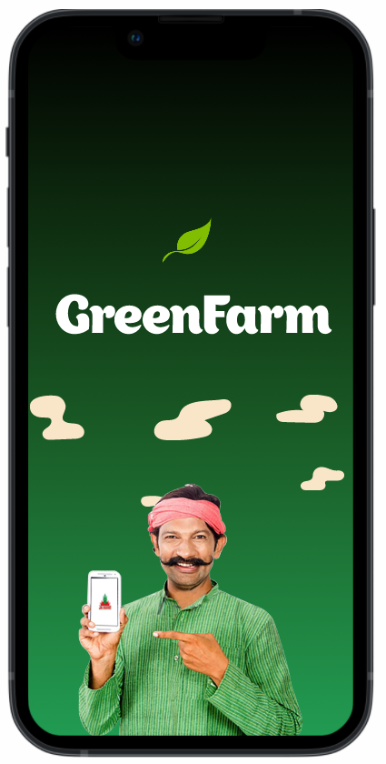 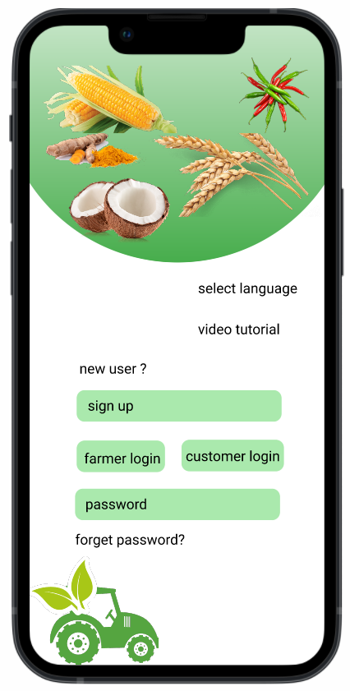

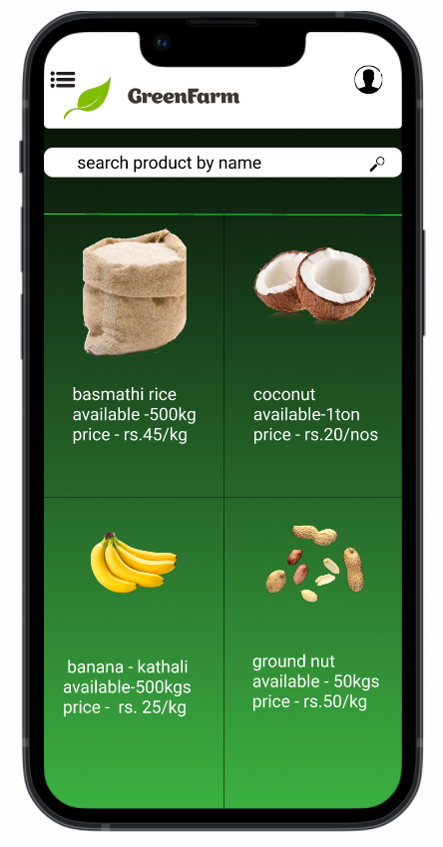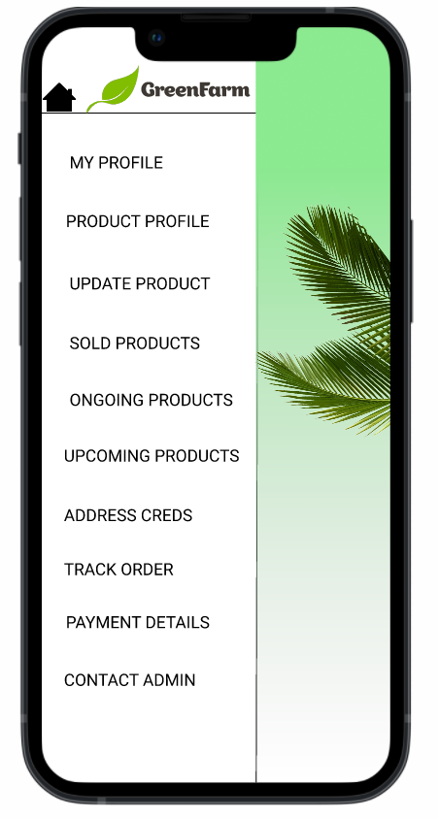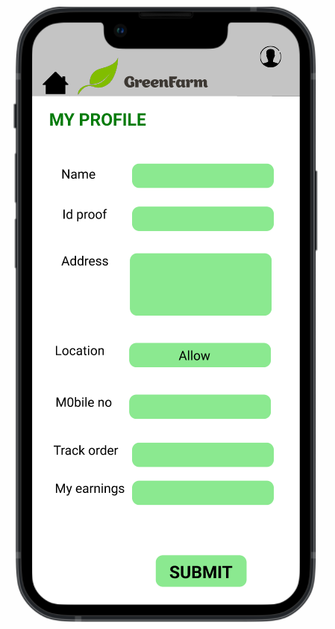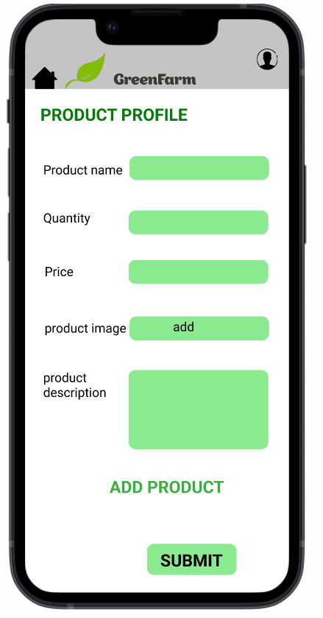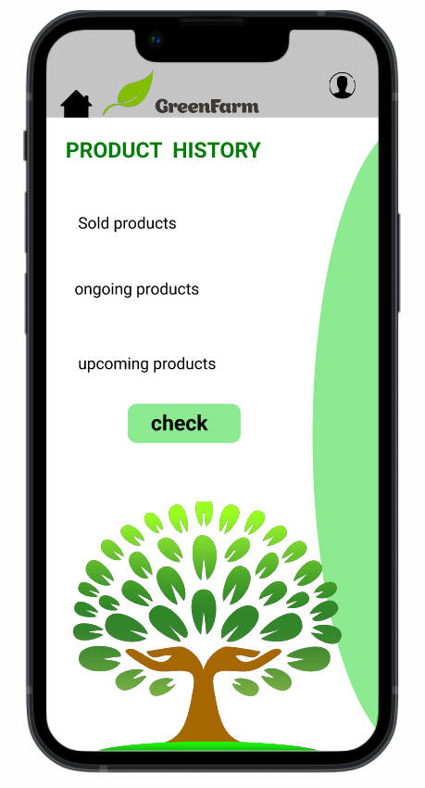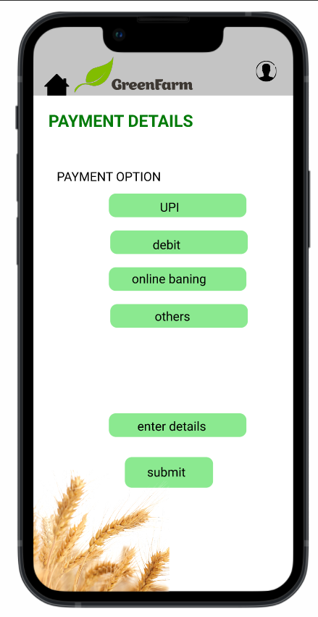 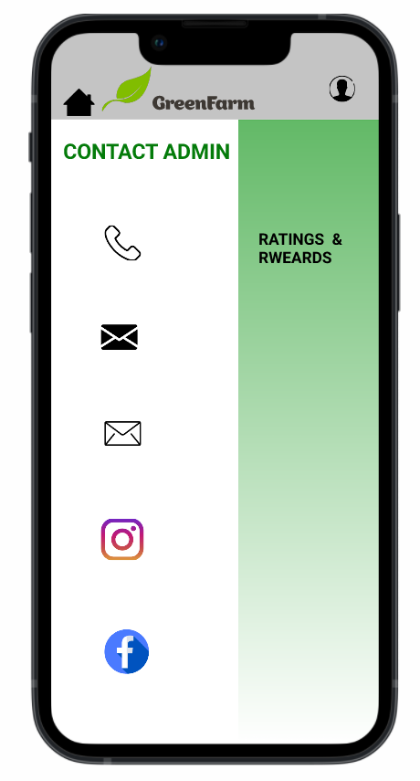

**Customer login**

** **

 

